A CAPTCHA SWITCH

Most of the websites today use a single CAPTCHA to secure the interface.As there are plenty
of CAPTCHAs available today, different CAPTCHA problems can be used to secure a single interface.

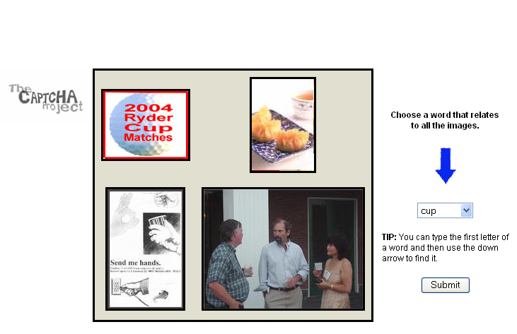 (0)

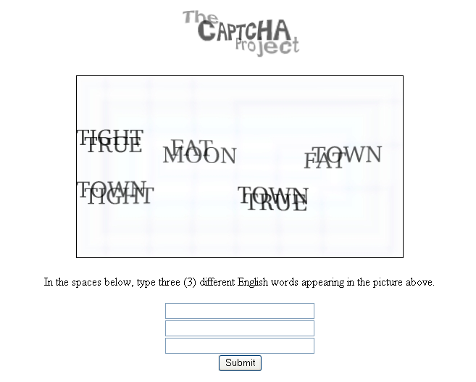 (1) ←-------------→ Login Interface
|
--------------------------------------- (A Random Number generator)
(0……..n)
----------------------------------------
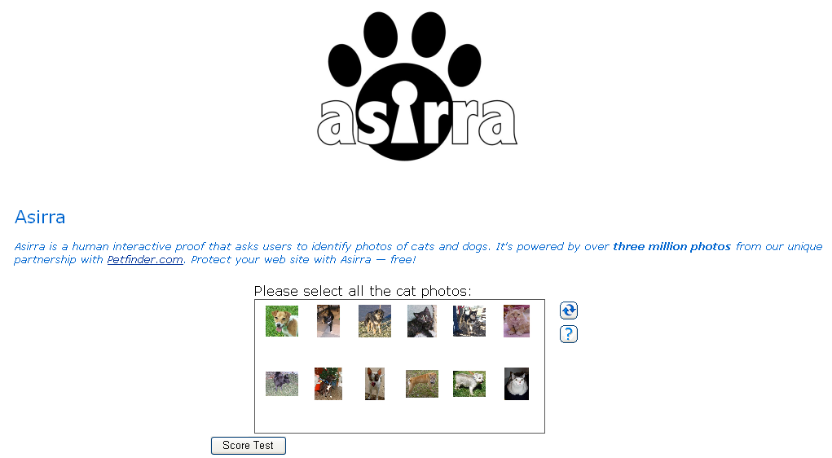 (2)

.
.
.
.

(n)

A random CAPTCHA is presented to the user in the beginning and / ( after a certain no. of unsuccessful tries ), before a login prompt is granted again.

